Planetary Orbits and Kepler’s Laws

Introduction
At first I believed I was dreaming... But it is absolutely certain and exact that the ratio which exists between the period times of any two planets is precisely the ratio of the 3/2th power of the mean distance.
— translated from Harmonies of the World by Kepler (1619)
The 16th century Danish astronomer Tycho Brahe and his team made the most accurate catalog of stellar and planetary positions in the ages prior to the invention of the telescope. Based on Tycho Brahe’s work, his German assistant Johannes Kepler deduced three laws of planetary motion around 1610. The entire catalog, called the Rudolphine Tables, was published in 1627.
Much later on, it was realized that these three laws were direct consequences of Sir Issac Newton’s law of universal gravitation (1687). The work of Tycho Brahe and Johannes Kepler still stands as a groundbreaking achievement in the ability to make patient and precise observations without the benefit of a telescope!

Materials needed:
- Simulations:
  - Gravity and orbits: https://phet.colorado.edu/sims/html/gravity-and-orbits/latest/gravity-and-orbits_en.html
  - Kepler’s second law: https://www.walter-fendt.de/html5/phen/keplerlaw2_en.htm
  - Elliptical orbits and Kepler’s second law: https://ophysics.com/f6.html
- Videos (while not recommended-these describe Kepler’s 3 Laws (Same as in module)
  - Kepler’s First Law of Motion - Elliptical Orbits (Astronomy)
  - Kepler’s Second Law of Motion (Astronomy)
  - Kepler's Third Law of Motion (Astronomy)

Part 1: Linking planetary orbits to Kepler’s Laws

Go to model: https://phet.colorado.edu/sims/html/gravity-and-orbits/latest/gravity-and-orbits_en.html
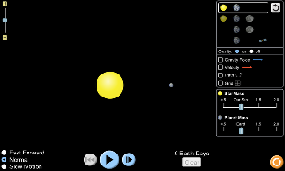

- Click on Model

- Click sun and planet
- Press PLAY, blue circle (with path/gravity/ velocity/grid ON, green circle) and leave for one cycle then PAUSE.

- What holds the planet in the orbit?
Gravity is the force that keeps planets in orbit around the Sun.

- What shape is the orbit? Use the screenshot to explain this.

Turn ON gravity force button (green circle) above.
- What direction do the forces face? Screenshot this as proof:

Turn the gravity OFF (green circle) above.
- What happens to the planet & why? Screenshot this as proof:
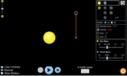

Now turn the gravity back ON and increase slightly the velocity of the plant by extending the red ‘v’ arrow of the planet, green circle.
- What happens to the planet in its orbit?

- What is the shape of the orbit when the velocity is slightly increased?

Now increase the velocity of the plant to a large extent by extending the red ‘v’ arrow.
- What happens to the planet in its orbit?

Now decrease slightly the velocity of the plant by diminishing the red ‘v’ arrow, green circle.
- What happens to the planet in its orbit?

- What is the shape of the orbit when the velocity is slightly decreased?

Now decrease the velocity of the plant to a large extent by moving the ‘v’ arrow in.
- What happens to the planet in its orbit?

- Now try to explain this in terms of v and gravity: Compose at least one complete sentence.

- Is the velocity constant throughout the journey? Describe what you observe about the velocity?

With the star and planet chosen and path/grid on, increase the size of the star by sliding the controller to 1.5/1.75/2.0, green circle.

- What do you notice about the orbit?

- What happens to the velocity on the path?

Now do the same but change the planet's mass 1.5/1.75/2.0 (blue circle).

- What do you notice about the orbit?

- Why do you think is the reason behind the observation that you see in your previous answer?

Part II: The Big E
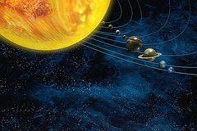

Kepler's three scientific laws describe the motion of planets around the Sun. In 1609, Kepler's laws challenged the long-accepted geocentric models of Aristotle and Ptolemy and followed the heliocentric theory of Nicolaus Copernicus by asserting that Earth orbited the Sun, proving that the planets' speeds varied and using elliptical orbits rather than circular orbits with epicycles. Most planet orbits are almost circles, so elliptical shapes are not obvious.
Calculations for the orbit of Mars first indicated to Kepler its elliptical shape, and he inferred that other heavenly bodies have elliptical orbits too.
“The big E” is the ellipse.

Simulations:

Elliptical Orbits & Kepler's 2nd Law: https://ophysics.com/f6.html

Kepler’s second law: https://www.walter-fendt.de/html5/phen/keplerlaw2_en.htm

Part II.A

Here are the directions for using a simulation to create the two ellipses.
Be sure you have watched the videos in Canvas!

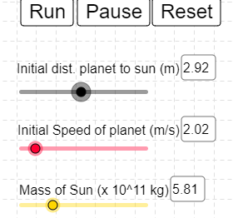
Go to: https://ophysics.com/f6.html

Click run, and observe what happens as the planet orbits the sun, on default settings.

Create two different orbits, by changing either the distance to the sun or the mass of the sun.

Make sure the orbit of the planet does not cross the sun.

Take a screenshot of your two orbits, and insert them into this doc.

- Along the planet’s elliptical orbit, find the place where the planet is closest to the Sun. This is called the perihelion. Label this location P.

- Along the planet’s elliptical orbit, find the place where the planet is farthest from the Sun. This is called the aphelion. Label this location A.

- Draw a line from the perihelion to the Sun and label it q.

- Draw a line from the aphelion to the Sun and label it Q (this line will cross the entire ellipse).

- Insert a screenshot HERE of your simulated ellipses, with points added (you can do this in google drawings) . If needed, you can attach them as you turn in.

- Define the following based on the diagrams you have created.

Elliptical:

Focus:

Foci:

Major axis:

Semimajor axis:

Perihelion:

Aphelion:

- How does your diagram model Kepler’s first law of planetary motion?
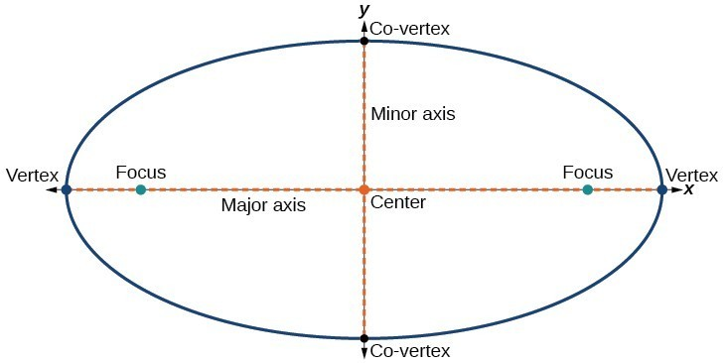

12.. Eccentricity is a measure of the deviation of an elliptical path from a perfect circle. In other words-how circular something is.

It is equal to the ratio of the distance between the foci (focuses) of the ellipse to the length of the major axis of the ellipse. By the way an ellipse is defined we can find these numbers from lengths of your two lines (q and Q). The distance between the foci is just the length of Q - the length of q. And the length of the major axis is the same as the length of Q + the length of q. So, if we label the difference of the lengths as f, and also label the sum of the lengths as d, then the eccentricity is:
e = f ÷ d.

Eccentricity ranges from zero (for a perfect circle) to values approaching one (for a very flattened ellipse).

Using your diagrams, fill in real data for your ellipses in the table below.

You will need to use a calculator in this part.

Ellipse Diagram | (q) Distance from Perihelion to the Sun m) | (Q)  Distance from Aphelion to the Sun (m) | Q – q = f | Q + q = d | (e) Eccentricity: f ÷ d  (Show Calculations)
1
2

Part II.B
Every planet in the solar system orbits the Sun in an elliptical path of varying degrees. Use the data for each object of the solar system and find the eccentricity (e = f ÷ d).
Object of the Solar System | (q) Distance from  Perihelion to the Sun (AU) | (Q)  Distance from Aphelion to the Sun (AU) | Q – q = f | Q + q = d | (e) Eccentricity: f ÷ d  (Show Calculations)
Mercury | 0.31 | 0.47
Venus | 0.72 | 0.73
Earth | 0.983 | 1.017
Mars | 1.38 | 1.67
Jupiter | 4.95 | 5.45
Saturn | 9.01 | 10.07
Uranus | 18.28 | 20.09
Neptune | 29.80 | 30.32
Pluto | 29.6 | 49.3
Ceres | 2.56 | 2.98
Halley’s Comet | 0.586 | 35.08
Vesta | 2.152 | 2.571

Check your values with this link: https://www.walter-fendt.de/html5/phen/keplerlaw2_en.htm

Questions:
- Compose a sentence about the relationship between a planet’s distance from the sun and the shape of its orbit.

- Looking at the data table of planetary orbits, do they all follow a pattern?

  - What pattern would you expect to see?

  - What do you actually see?

Part III: Kepler’s Laws
Objective: To review Kepler's three laws; to determine the properties of an ellipse; to relate these properties to the orbits of planets.

Note: This part of the lab consists of questions and calculations only. You don’t need to use any of the web-based simulations here.

Part 1: Kepler’s First Law
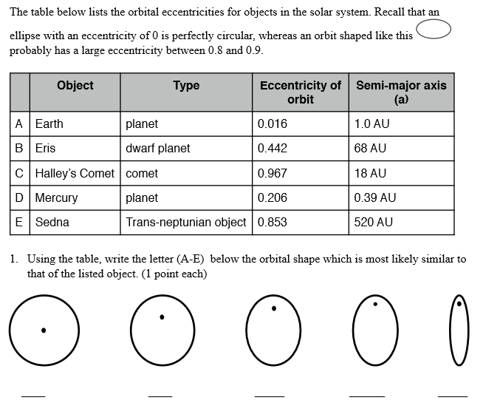
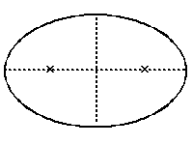
2. Eccentricity is a measure of the degree of “flattening” of the ellipse. Mathematically, the eccentricity of an ellipse is defined as the distance from a focus to the center of the ellipse divided by the length of the
semi-major axis.

Estimate the eccentricity of this ellipse: _______

To calculate the eccentricity, use this formula:
Calculated eccentricity:
_____________________________
Distance between foci
Length of major axis

Part II. Kepler’s Second and Third Law

Kepler's second law, which states that as a planet moves around its orbit it sweeps out equal areas in equal times, is often a difficult, totally confusing concept to picture, let alone understand. Since it is just a description, we are going to ignore it and state what the second law really means: that a planet travels faster when it is nearer to the Sun and slower when it is farther from the Sun.

- Examine the next figure of the "Planet D" orbiting the Sun “A” in a counterclockwise direction and fill in the blanks with the correct letter:
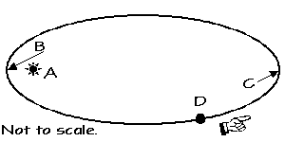
  - Focus ______
  - Aphelion ______
  - Perihelion _____
  - Increasing speed: ____ to ____
  - Decreasing speed: ____ to ____
  - Planet has greatest speed ____
  - Planet has lowest speed ______

- Now, state Kepler's Second Law in your own words and give your reasoning as to why planets "behave" this way:

Kepler's Third Law relates the period (P) it takes a planet to go around the Sun in an orbit of a given semi-major axis (a). Assume that the mass of the Sun is much, much greater than any of the planets (which it is), and measure P in years and a in astronomical units. The simplified relationship (formula) is:

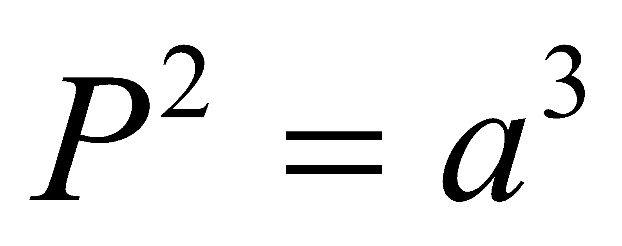

- The following two orbits have about the same value for a. How do their values of P compare?

- Why is that? (think about what Kepler’s laws actually say)
________________________________________________________________________________________

________________________________________________________________________________________

- Kepler's Third Law means that all orbits with the same semi-major axis have the same period. Explain how this can be when the orbits look so different, and why this makes sense.

Analysis Questions

- What is the maximum eccentricity that an ellipse can have? ___________ What is the shape of an ellipse with that eccentricity?__________________

- What is the minimum eccentricity that an ellipse can have? ___________ What is the shape of an ellipse with that eccentricity?________________________

- Why do you think the distance to a planet from the sun is given as an AVERAGE, rather than an exact distance?

- Imagine a space ship is orbiting the Earth with a constant orbital speed. Sketch the system below and add arrows to show the direction of the force on the spaceship at each of the points shown in the orbit below.

= Spaceship

E

- Assume the spaceship in the diagram is an alien ship with a deflector screen which can make it immune to gravity. If the ship is traveling along in its orbit and it turns off its engines at the exact same time as it turns on its gravity deflector shield, what will happen? Choose one answer and defend it.

- The ship will continue traveling in a circle.
- The ship will slowly drift outward from the orbit.
- The ship will travel straight out perpendicularly from the circular orbit.
- The ship will spiral down to the Earth.
- The ship will come to a full stop, hovering above the Earth

